Training fiche
Title |  | Business models for MSMEs in the post-COVID era
Keywords (meta tag) |  | traditional business models, sharing economy, platform economy, on-demand model, resilience
Provided by |  | HÉTFA
Language |  | English
Training area (X where applicable)
X | Innovation & Servitization
X | Digital Transformation
X | Localization
X | Sustainability
ESCO competencies and skills
[please highlight the competencies and skills that are aligned with the definitions of the ESCO and are developed by each unit in this module]
- Transversal skills and competences
  - Social and emotional skills
  - Critical thinking
  - Analytical thinking
  - Problem-solving
  - Self-management
  - Business management
  - Adaptability
  - Resilience
  - Creativity
  - Networking
  - Initiative
  - Flexibility
  - Openness
  - Understanding complexity
  - Cooperation
  - Empathy
  - Innovation
  - Leadership

- Skills
  - Technological skills
  - Product marketing
  - Digital marketing
  - Digital skills
  - Communication
  - Cooperation
  - Emotional intelligence

- Knowledge
  - Business management
  - Online learning and training
  - Advertising
  - Cloud computing
  - Big data
  - E-commerce
  - Artificial intelligence
  - IoT
  - Digital literacy
  - Cybersecurity
  - Data mining and analysis
  - Sustainability
  - Well-being
  - Climate change
  - Social media management

Teaser
Get a step-by-step guide to building your own business model - and start seeing success right away.
Profitable and sustainable: Explore the keys to building a business model that can stand the test of time.
The ultimate guide to business models: Unleash your company's full potential with expert insights and strategies.
Objectives / goals / learning outcomes
- Understand the concept of business models (BM) and why they are important for an MSME
- Know how traditional MSME BM work, what are the basic elements
- Recognise what has changed in MSME BMs in the 21st century and in the post-COVID era
- Set up your own BM
- Reach out for more information and support in further developing your BM
- With a hypothetical example start-up (called HIDS) you can find an example for a one-pager, business pitch, cash-flow tables and financing strategies
Description
This training module describes what business model means, explains the nature of traditional and 21st century business models and provides tool for building your own business model.
Checklist of benefits for entrepreneurs
[list at least three benefits]
✓ Understanding what business model means;
✓ Understanding the traditional and 21st century business models
✓ Understanding how to create their own business model
Contents arranged in 3 levels
Module: Business models for MSMEs in the post-COVID era

UNIT 1: MSME business models (BM)
The most important common objective of enterprises is to create value and make profit. Companies differ from each other in terms of how they plan to do that. The business model is the concept for the operational and profit-making model of an MSME: turning it into a business plan defines the exact function of how the company works and how it makes profit.
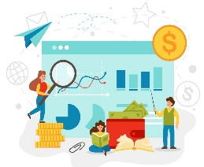

REVENUES – EXPENSES = PROFIT

Sidenote: there are also so-called ‘social enterprises’. Their primary goal is to have a social impact, and not to maximize profit for the sake of owners – yet they also have to have a good business/operational plan that allows them to be sustainable (see RESTART Training Module 5. Sustainable, social, and green entrepreneurship).

UNIT 1: MSME business models (BM)
1.1 Basic models

Costs/Expenses
- input materials (supplies)
- production tools (machines, equipment, IT)
- location (office, factory, shops, etc.) costs
- human resources costs (including all tax and social contributions!)
- marketing and sales costs
- administrational costs (registration fees, accounting, administration)
- cost of access to capital
- expenses of financial activities (exchange rate loss, interest paid, etc.)
- ! calculate all taxes, and fees to be paid
Revenues
- revenues from sales (operating revenues)
- revenues from subscriptions, fees, licenses
- revenues from activities indirectly related to your key profile (e.g., if you have a warehouse and rent half of it to someone else
- Revenues from financial activities (interest paid on your funds, etc.)

The basic model differentiates between fix and variable costs:
Fix costs: that need to be paid regardless of how much product or service you sell.
- Fix costs are for example: the cost of office/warehouse/shop, if you decide to rent/buy one, the cost of administration for an MSME (an accountant).
- On the short term, fix costs can also include employment costs (as it is not easy to hire/lay off personnel due to labour market conditions and regulations) but many count them as variables on the longer run (depending on the flexibility of the given labour market & employment scheme)
- On the short term, amortisation/depriciation costs are also fix (if you buy an expensive equipment, you will be able to write it off over the next couple of years)
Variable costs depend on how much you are producing
- Typical variable costs are the costs of the supply you need – input materials – for your production
- One-time, set-up costs include legal fees for creating the company, logo and web design, etc.
- Calculate all costs! Use online tools if needed. Consider cost-efficient solutions.

The basic model must be built on a preliminary market research that investigates in details:
- Your potential customers – the size and availability of the population as well as their capacity to pay for your products/services. Learn about the specific preferences, details they currently buy and try to access their potential demand for something you aim to offer.
- Your potential competition – the companies already present in the given market, their level of price/quality, their reach regarding the customers, their marketing and sales strategies, etc.
- Your potential collaborators – let those be your future suppliers or other small businesses with whom you are not competing directly but cooperate (e.g. opening up a joint shop, sharing logistics, etc.)
- There are several ways and expert strategies to approach the research and do it yourself based on sufficient data or have someone do it for you.

Section 1.2: Rules of thumbs

A business model is a general framework, a main and general approach to running your business. The business plan builds on this, with a more detailed and structured set of information, tailor-made for your business. In a slightly different approach, the business model establishes your revenue-making process while the business plan defines your goals and strategies. In all concepts, the business plan is derived from the business model.

When setting up your business plan:
- use professional calculation tools (BM software, apps, etc.)
- do not hesitate to ask for help (from a more experienced entrepreneur, from an accountant, from a marketing specialist, from the local chamber of commerce, the EBN network, etc.) If you do not get sufficient help from one, go to another, do not give up!

Calculate costs and revenues on at least a yearly basis, better on a 3-year basis in order to:
- allow for all types of costs and revenues to show
- allow for trends and dynamics to emerge

Look at issues from all angles to find hidden costs and potential for additional revenues.
- In case of costs, think about not only regular costs but potential, infrequent items as well (such as legal costs, etc.). Some hidden costs lie in suboptimal work and process organisation.
- In case of revenues, think of your assets from a different perspective - can you make more money with them? What is the most efficient way of using your assets? (If you have a truck that is not always full – can you combine your logistics with another MSME and rent out parts of your routes/cargo hall?

Differentiate between costs and investments! (in other terms: expenses and expenditures). Be motivated to cut costs where it does not hurt, but:
- Make sure you are aware of the quality of supplies, inputs, and human resources you get for your money
- Investments are supposed to move your enterprise forward and bring you more profit in the future. Do not underestimate their necessity.

Section 1.3 Typical ways to financing an enterprise
Financing the start (e.g. securing funds while there is no track record yet on performance) | Financing regular business operations | Financing larger investments (e.g. new equipment, new production site, etc.) | Financing innovation, research, development
The owner’s own funds (bootstrapping, sweat equity) | Sales revenues shall finance the operations, at least on a longer term | From own saved funds / capital reserve | From own saved funds / capital reserve
The “3F” – investment from Friends, Family and Fools | Short-term liquidity challenges can be managed by own funds, or… | From specific bank loan (usually with mortgage or other security/guarantee conditions) | Using governmental or EU funds to co-finance the investment
Business angel investment, sometimes venture capital (only for scalable start-ups) | … bank credit specifically for liquidity management | Renting or leasing | Based on contracts from clients (procurement of innovation)
 | … matching and managing payment conditions set with suppliers and buyers | Using governmental or EU funds to co-finance the investment

UNIT 2: Traditional business models (BM)

We call “traditional business models” the models defining our economies before they were completely disrupted by the emergence of transformative IT solutions – first the internet, then mobility, and nowadays ML and AI (machine learning and artificial intelligence).
In other words, the traditional models characterize the typical business behaviours we see throughout the 20th century.

Sidenote on industrial revolutions: throughout economic history, major innovations have forced existing business models to transform and adapt to new possibilities and conditions. Historians credit the emergence of farming, later the emergence of manufacturing responsible for a complete shift in existing “business models”. The first industrial revolution (due to the steam engine and mechanization), the second (due to the invention of electricity and division of labor in industries), the third (by establishing global production chains in the 2nd half of the 20th century), and the fourth (supported by IT and robotization) all forced economic actors to re-think their strategies and business models. The 5th revolution, driven by new IT developments and artificial intelligence, is at our doorstep – we are experiencing the shift to new models in our everyday.

Section 2.1 B2C

From Business to Consumers - Traditional small businesses exist since the dawn of human societies. They are simply built on the realization that a small company – originally within a family or with a specific group of professionals (guilds, etc.) – can produce/offer goods and services for other people - for their communities – their customers.
If you want to reach out directly to your customers, you must find sales opportunities to meet them.

In a B2C business model, the entrepreneur has to plan for….
Producing or procuring the products/services
- Either directly producing from basic supplies/supplied parts,
- Or procuring goods
The logistics and point of sales
- Where to store and how to get the product/services to the point of sales
- Where to meet the customer – point of sales
Marketing and promotion
- How to convince the customers to buy these products/services
- How to brand, market, promote the company itself
In return, …
- Gets direct response from the customers on the products/services
- Accesses timely data on sales

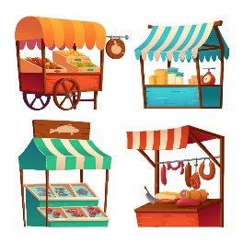

Section 2.2 B2B
From Business to Business (and, similarly, Business to Government) - Selling your goods and services to another company or public/governmental agencies differs from simple B2C businesses in several aspects. Most importantly, you have to deal with a much smaller number of clients but in return, it is harder to get them and it is more crucial that you keep them (or at least build a good portfolio so you will not be depending on 1 or 2 sole buyers.)

In a B2B business model, the entrepreneur has to plan for….
Producing or procuring the products/services
- Directly producing from basic supplies/supplied parts, setting up services
Reaching business/governmental buyers or retailers
- Either selling to other companies and /or public actors
- Or selling to distributors, retailers who are then on responsible for getting the product to the market
Marketing addressing business/governmental buyers (different marketing than B2C)
- How to convince the clients/retailers to buy these products/services
- How to brand, market, promote the company itself
In return, …
- Production in larger quantities is usually necessary
- Longer-term, more stable contracts can help the sustainability of the company

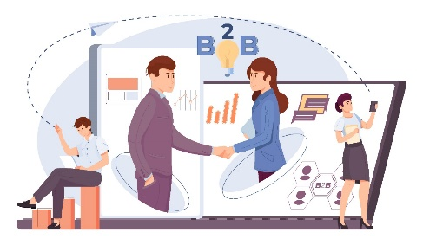

Section 2.3 Franchise
In the franchise model, the concept is based on one successful model, that has proven itself to work and make a profit in a given environment. The owner of this model – the franchiser – sells the “recipe” – to the franchisee. The recipe includes the exact business model, the brand and respective intellectual property, often the connections to supplies/suppliers, and somewhat strict regulations on operations (to protect the main brand).

In the franchise model, the entrepreneur has to plan for….
Producing or procuring the products/services
- Based on a strict recipe, usually with strong franchise requirements
- Often with direct access to suppliers/suppliers
The logistics and point of sales
- Where and how should the new franchise shop open?
- Is there sufficient local demand for it?
Marketing and promotion
- Done on the franchise level in general
- Yet a local marketing (at least regarding the launch) needs to be conducted
In return, …
- There is no need to invent a whole business from scratch
- Franchise fees are paid to the franchise owner

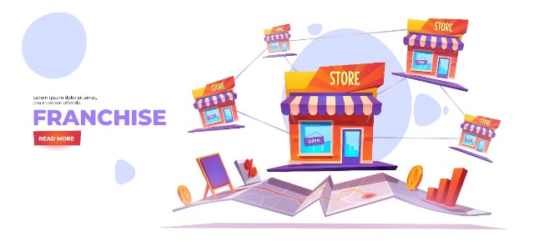

Section 2.4 MSMEs in a domestic economy

When an MSME operates in a specific local environment - in its city, county, region, or country – it has to meet specific requirements:
- Meet the requirements of local and national regulation – in terms of taxation, accounting, and administration, but also work safety, labor laws, environmental hazard management, and so on. These conditions may differ across countries, and although they are mostly (though not fully) harmonized across the European Union (under the concept of the European Single Market).
- When setting up your business model, make sure that the competition from another country - that has to meet fewer requirements - is not endangering your economic success. This is especially important in cross-border areas.

Operating only on or below a domestic market also has advantages, compared to being an international/global economic player:
- To be innovative in the global market is a serious challenge. But on the local/national level, you can be innovative by imitation/adaptation – that is, taking a good business idea and adapting it to the local conditions. (Make sure that you are not violating any intellectual property rights (IPRs).
- It is a key advantage for a company in reaching its customers to speak the local languages, and understand the local culture and society. Yet, especially due to a global business culture more and more uniform (trends set by global social media and global services) and due to the availability of high-level translation and chatbots by AI solutions, expect this “protective” nature of being only a national player to diminish in the close future.

UNIT 3: Business models of the 21st century

- As said in the previous chapters, the emergence of technology – especially information and communication, digital technologies – changed the economy during the 2nd half of the 20th century, opening opportunities for the globalization of production and services, and today’s technological developments allow for an even wider set of new business models to emerge. The European Union has a digitalization strategy that sets targets for the future and allocates resources to reach those.
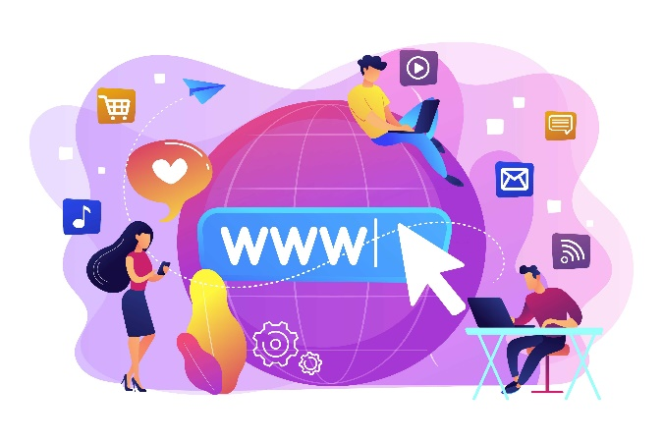

Section 3.1 European and global markets
The globalization of media and business in the 2nd half of the 20th century paved the way for the global production and innovation chains that surfaced at the end of the 20th century. This global economic model was built on optimizing cost-effectiveness (often neglecting the negative human, democratic and environmental aspects also associated with low-cost production).

While several events in the 21st century have slowed down or even turned back globalization trends (such as geopolitical events, the rise of China’s independent research, development, and innovation (R&D&I) capacities, the COVID-19 crisis, the realization of the effect of global transport on climate change, the current energy crisis and oil/gas dependency, etc.) several other factors further enhanced global production and distribution of products and services (such as wider and wider availability of broadband internet connections, the development of distant working and global, virtual teamwork (RESTART Training Module 1), overcoming several language barriers via machine learning technologies, etc.).

The European Union has made it a key priority to increase European economic competitiveness by creating the Single European Market, which is built on a common set of regulations and standards that allow European companies to relatively easily operate across borders, offer products and services, use banking, legal, taxing and consultancy services without the necessity of opening up daughter companies in each of the other countries.
To operate on the European market, familiarize yourself with the respective regulations, require an EU VAT number, and make a detailed market analysis of whether it is worth it for your company to invest in internationalization.
Not all new companies must directly compete on the global market, but the economic milieu, the availability of options, and general trends must make each new company aware of their position not only in the domestic but in the European and global markets as well.

Section 3.2 Start-ups

Most businesses start as micro- and small businesses (though there are examples of the opposite as well, large companies created by mergers, acquisitions, or larger holdings breaking up). Yet, at a very early point, they can be set on one of two significantly different tracks: they either become a small business or a start-up.
What is the difference?
- Small businesses aim to conduct their business for a profit, make a living, serve their customer but are not a dominant player in their economy.
- Start-ups have the potential for sudden and significant growth by “scaling up” – usually by using technology – they can grow to be an international player within a small period of time

Start-ups build their business model on technology that allows them not only to duplicate or triple their economic performance but to multiply by tens, hundreds, or thousands in just under a short period of a couple of months/years.
Successful start-ups are often “born-global” – even from the start, they offer products – but much more often, services – that are demanded across the globe, maybe with minor localization efforts.
Start-ups are always very innovative and include a high-risk factor. Just a small share of start-ups succeed on the international, and an even smaller share on the global scale.
Start-up funding must include risk-friendly capital involvement at the early stages. A typical cycle:
Own capital, 3F → Business angel investment or crowdfunding → Venture capital → Merger & Acquisition → Stock market

Section 3.3 Other new business models
The new business models described below are sometimes working independently, but sometimes as a combination of the models below. In each case, a unique decision must be made about the ideal combination of these elements.

Sharing economy:
The sharing economy as a business model is built on sharing resources, existing goods, and services among potential users. It is almost always built on the use of technology as a tool for sharing. Sharing may include the creation, production, distribution, sale, or use of the given products and services. The sharing economy can also be B2C (for example Airbnb) or B2B (e.g. coworking offices).
Promoters of the sharing economy often claim that it is a resource-efficient and environment-friendly solution. Others point out that the sharing economy often allows tax evasion and neglects otherwise existing industrial regulations.

Platform economy:
Platform economy is similar to the sharing economy but emphasizes the role of the technological platform that connects the different small economic agents operating under the platform. Let it be Amazon or Uber, the platform economy allows individuals otherwise not capable of reaching a wide circle of customers to reach out and offer their products/services. The business model is also characterized by serious imbalances of power (between the platform and the individual players).

On-demand model:
The on-demand model is also connected to technological developments. It offers a unique chance for the client to time the consummation of the product/service exactly to their preference. Modern food delivery services (foodpanda, Wolt) and streaming media (Spotify, Netflix, etc.) are built on this model.

Servitization and subscription model:
The servitization is built on the concept of re-interpreting traditional products and one-time services as a continuously provided series of services, usually by supporting ongoing improvements, updates, upgrades, maintenance, and customer service. They can be charged monthly, bi-annual, or annual subscription fees. Learn more about servitization in the RESTART Training Module 6.

Freemium model:
The freemium model offers a simplified construction of the services for a free subscription, but more advanced – premium – features are priced. This helps the branding, marketing, and communication of the service by getting it to a large set of customers while generating income from professional clients. Such examples are Spotify, LinkedIn or Evernote and many others.

Localization model:
Localization is built on the idea of a general product/service being adapted to the local environment, to the given specific societal-economic conditions (language, preferences, cultural values, purchasing power, etc.) In this case, you have to make sure that you have the legal rights to adapt the original product/service.

UNIT 4: Setting up your own business model

In this last chapter we point you toward the most important elements of setting up your business model. This will include drawing up the strengths, weaknesses, opportunities, and threats of your business idea (the SWOT Analysis), based on the preliminary market research you conduct. Then elaborate on the model and find mentors and partners to work with!

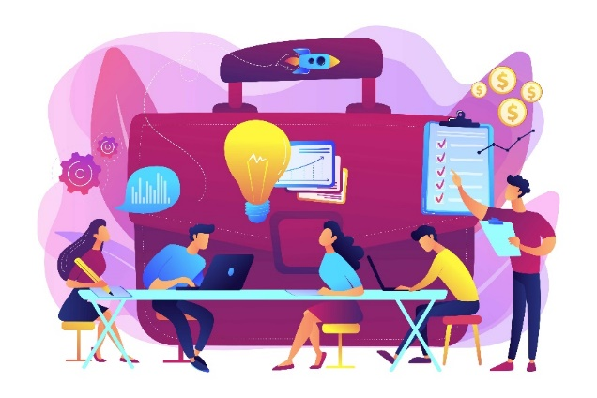

Section 4.1 SWOT

First, conduct your market research – or have someone conduct it for you – as discussed in Chapter 1.1. Be familiar with the potential customer base, their preferences and demand capacity, with your competitors, and with potential alliances. Then position yourself, and your project idea and try to identify your planned business’ strengths, weaknesses, opportunities, and threats. Put them down in a matrix:
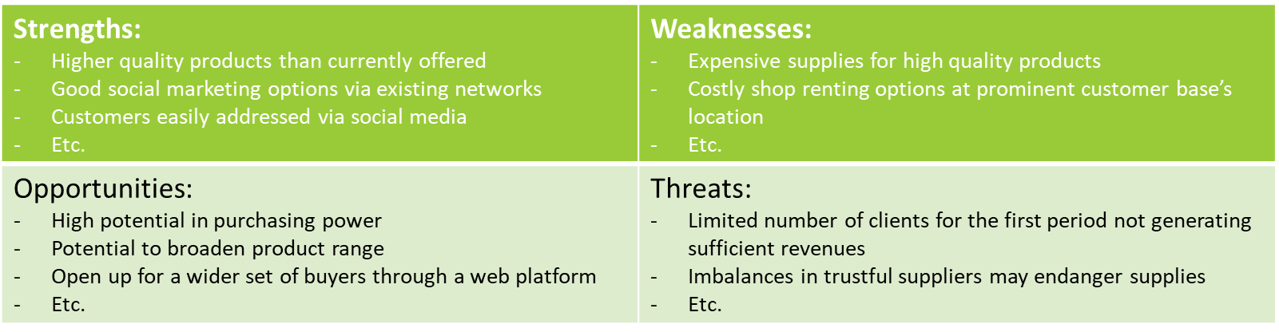
Further support: examples, best practices, step-by-step guide

Based on your SWOT, you will be able to determine the main trends for your business model.
- Are you capable of reaching out to customers with a high purchasing power and offering high-quality exclusive products? Or rather supply a wider set of customers with less exclusive, but good quality/price ratio products?
- Are you capable of controlling your supplies reliably or are you at the mercy of larger powers on the suppliers’ side? Are your supplies domestic or do you rely on imported inputs?
- Are you reaching for an offline sales opportunity or better to go online? Are you able to address your customers directly and operate a webshop or rather turn to an online marketplace – a platform?
Based on your answers to such questions, you can sketch up the main design framework for your business model.

Section 4.2 Techniques and tools

For putting together your business plan, you have to reach out to various techniques and tools:
A.) You can – and are encouraged – to use an old-school spreadsheet software – Excel, etc. – and do the calculations on the cost/expense side and the revenue side
B.) You can also – and be ready to use more than these options! – use online tools/apps designed to create business models. Certain examples are:

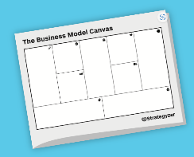

Once you have your business model figured out, make sure you create the followings:
- One-pager (very concise description of the project idea and business model)
- A 5-min pitch (how would you explain very fast what the key concept is?)
- A draft expenses-revenues plan for the first 1-3 years
- A draft cash flow plan for the first 1-3 years
- A capital financing plan for the first 1-3 years
- A marketing plan for the first 1-3 years

Section 4.3 Alliances and networking
Your last homework is to find alliances, mentors, and supporters – do the networking!
- Contact:
- Local and European chambers of commerces, chamber’s associations
- Local and European sectoral associations
- Local and European business support centers
- Innovation labs , innovation centres (in case of innovative ideas) and accelerators
- Co-working offices
Remember: not everyone will be able to help you with useful information or real help but keep on looking for support, mentors, and partners. Never hesitate to learn from others. Remember: not only good practices but failures and bad experiences are also extremely useful lessons for the future.

Contents in bullet points
Unit 1
- The business model is the operational and profit-making model of an MSME: it is an exact function defining how the company works and how it makes profit.
- The basic model must be built on a preliminary market research that investigates potential customers, potential competitors and potential collaborators.

Unit 2
- B2C: The traditional models characterize the typical business behaviors we see throughout the 20th century.
- B2B: Selling goods and services to another company or public/governmental agencies differs from simple B2C business in several aspects
- Franchise model: The owner of this model – the franchiser – sells the “recipe” – to the franchisee.

Unit 3
- The globalization of media and business in the 2nd half of the 20th century paved the way for the global production and innovation chains that surfaced at the end of the 20th century.
- The new business models are often working independently, but sometimes as a combination of sharing economy, platform economy, on-demand model, servitization, freemium & and subscription model, takint into account localisation.

Unit 4
- A SWOT analysis helps to identify the business’ strengths, weaknesses, opportunities, and threats.
- New entrepreneurs should find alliances, mentors, and supporters and keep networking.

5 glossary entries
[5 glossary entries with a brief description]
Business model: The business model is the concept for the operational and profit-making model of an MSME: turning it into a business plan defines the exact function of how the company works and how it makes profit.
Expense: Business expenses are the costs of running a company and generating sales.
Revenue: Revenue refers to the income a business generates from its normal operations. It is the gross or top-line income figure from which expenses are subtracted to calculate net income.
Business plan: A business plan is a written document that outlines the specific strategies, goals, and tactics that an MSME (micro, small, and medium enterprise) will use to achieve its operational and profit-making objectives. Essentially, a business plan is a blueprint for the company's success, providing a roadmap for its growth and development over time.
Start-up: Startups are young companies founded to develop a unique product or service, bring it to market and make it irresistible and irreplaceable for customers. Rooted in innovation, a startup aims to remedy deficiencies of existing products or create entirely new categories of goods and services, disrupting entrenched ways of thinking and doing business for entire industries.
Bibliography and further references
- AI Multiple. (2023). Innovation Procurement in 2023: What it is & Best Practices. https://research.aimultiple.com/innovation-procurement/
- Belmejdoub Quotb, Amine. (2016). Business Model Canvas: Google Report. 10.13140/RG.2.1.4241.9601/1. https://www.researchgate.net/publication/301675127_Business_Model_Canvas_Google_Report
- Bplans. (2022). How to Estimate Realistic Business Startup Costs — 2022 Guide. https://articles.bplans.com/estimating-realistic-start-up-costs/
- Bplans. Business Calculators. https://www.bplans.com/business-calculators/
- Brecht, Patrick & Hendriks, Daniel & Stroebele, Anja & Hahn, Carsten & Wolff, Ingmar. (2020). Business Model Validation - How B2B Startups can use Business Experiments. https://www.researchgate.net/publication/347355881_Business_Model_Validation_-_How_B2B_Startups_can_use_Business_Experiments
- Britannica. (2023). The first Industrial Revolution. https://www.britannica.com/event/Industrial-Revolution/The-first-Industrial-Revolution
- Business Europe. Alliance for a Competitive European Industry. https://www.businesseurope.eu/alliance-competitive-european-industry
- CFI. (2023). Scalability. https://corporatefinanceinstitute.com/resources/management/scalability/
- CFI. (2023). Variable Costs. https://corporatefinanceinstitute.com/resources/accounting/variable-costs/
- Code Brew Labs. (2021). Understanding the On-Demand Business Model. https://www.code-brew.com/understanding-the-on-demand-business-model/
- Coworker. (2018). What Is Coworking? https://www.coworker.com/mag/what-is-coworking
- Deloitte. (2019). The rise of the platform economy. https://www2.deloitte.com/content/dam/Deloitte/nl/Documents/humancapital/deloitte-nl-hc-the-rise-of-the-platform-economy-report.pdf
- DeVry University. (2020). The Impact of Technology on Business: A Lesson in Disruption [infographic]. https://www.devry.edu/blog/impact-of-technology-on-business-infographic.html
- Eban. (2018). Angel Investing Explained. https://www.eban.org/angel-investing-explained/
- Enterprise Europe Network. Find your local contact point. https://een.ec.europa.eu/local-contact-points
- Enterprise Europe Network. https://een.ec.europa.eu/
- Entrepreneur. (2014). 6 Great Business Models to Consider for a Startup. https://www.entrepreneur.com/business-news/6-great-business-models-to-consider-for-a-startup/233451
- Eubic. Europe’s leading innovation partner network, fast-tracking your connectivity and certifying your value. https://ebn.eu/
- Eurochambers. (2020). Who are we. https://www.eurochambres.eu/about/who-we-are/
- Eurofound. (2023). Employment and labour markets. https://www.eurofound.europa.eu/topic/employment-and-labour-markets
- European Chamber of Commerce. https://www.eurchamber.com/
- European Commision. (2022). EU programmes and funds financed from the EU budget and NextGenerationEU. https://commission.europa.eu/funding-tenders/find-funding/eu-funding-programmes_en
- European Commision. (2022). European Digital Innovation Hubs Network. https://european-digital-innovation-hubs.ec.europa.eu/home
- European Commision. (2022). Venture capital. https://single-market-economy.ec.europa.eu/access-finance/policy-areas/venture-capital_en
- European Commission (2022). Digital Strategy. https://commission.europa.eu/publications/european-commission-digital-strategy_en
- European Commission (2022). Internal Market, Industry, Entrepreneurship and SMEs. https://single-market-economy.ec.europa.eu/sectors/tourism/eu-funding-and-businesses/business-portal/internationalisation-tourism-businesses/international-market-selection_en
- European Commission (2022). Leading innovation through EU research. https://european-union.europa.eu/priorities-and-actions/actions-topic/research-and-innovation_en
- European Commission. (2022). Information and communication technologies. https://ec.europa.eu/regional_policy/policy/themes/ict_en
- European Commission. (2022). Intellectual property rights. https://commission.europa.eu/business-economy-euro/doing-business-eu/intellectual-property-rights_en
- European Commission. (2022). Single market and standards. https://single-market-economy.ec.europa.eu/single-market_en
- European Commission. (2022). Social enterprises. https://single-market-economy.ec.europa.eu/sectors/proximity-and-social-economy/social-economy-eu/social-enterprises_en
- Evernote. https://evernote.com/
- Failory. (2022). The Top 20 Accelerators & Incubators in Europe in 2022. https://www.failory.com/blog/accelerators-incubators-europe
- Forbes. (2021). Researching A New Market? Follow These 15 Expert Strategies. https://www.forbes.com/sites/forbesbusinessdevelopmentcouncil/2021/01/29/researching-a-new-market-follow-these-15-expert-strategies/?sh=70b17eb8dabc
- Foss, Nicolai & Saebi, Tina. (2015). Business Models and Business Model Innovation. 10.1093/acprof:oso/9780198701873.003.0001. https://www.researchgate.net/publication/299874833_Business_Models_and_Business_Model_Innovation
- Franchise Business Review. (2018). The Franchise Business Model 101 – Introduction and How Does It Work. https://franchisebusinessreview.com/post/franchise-business-model/
- Freepik. https://www.freepik.com/free-vector/franchise-small-business-branch-expansion-banner_8188895.htm#query=franchise&position=0&from_view=search&track=sph
- Full Scale. (2020). Business Model Vs Business Plan: What’s the Difference? https://fullscale.io/blog/business-model-vs-business-plan/
- Geekflare. (2022). Create the Perfect Business Plan Using These 9 Tools. https://geekflare.com/business-plan-software/
- Geissdoerfer, Martin & Pieroni, Marina & Pigosso, Daniela & Soufani, Khaled. (2020). Circular business models: A review. Journal of Cleaner Production. 277. 123741. 10.1016/j.jclepro.2020.123741. https://www.researchgate.net/publication/343810965_Circular_business_models_A_review
- Gobookmart. (2022). 8 Books To Read If You Are Thinking of Starting A Company. https://gobookmart.com/8-books-to-read-if-you-are-thinking-of-starting-a-company/
- Growthink. (2023). Business Model vs. Business Plan. https://www.growthink.com/businessplan/help-center/business-model-vs-business-plan
- Gust de Backer. (2022). Market Research (2023): 12 Techniques for Effective Market Research. https://gustdebacker.com/market-research/
- Harvard Business Review. (2007). The Innovation Value Chain. https://hbr.org/2007/06/the-innovation-value-chain
- Harvard Business Review. (2015). What Is a Business Model? https://hbr.org/2015/01/what-is-a-business-model
- Harvard Business School Online. (2021). 6 PROS AND CONS OF GLOBALIZATION IN BUSINESS TO CONSIDER. https://online.hbs.edu/blog/post/pros-and-cons-of-globalization
- Hubspot (2023). How to Do Market Research: A Guide and Template. https://blog.hubspot.com/marketing/market-research-buyers-journey-guide
- Indeed. (2022). Expenditures vs. Expenses: Definitions and Key Differences. https://www.indeed.com/career-advice/career-development/expenditures-vs-expenses
- Indeed. (2023). Business Model vs. Business Plan: What’s the Difference? https://www.indeed.com/career-advice/career-development/business-model-vs-business-plan
- Institute of Entrepreneurship Development. (2019). The 4 Industrial Revolutions. https://ied.eu/project-updates/the-4-industrial-revolutions/
- International Trade Administration. Research Foreign Markets. https://www.trade.gov/international-market-research
- IntoTheMinds. (2020). Market research in the EU: The 10 best data sources. https://www.intotheminds.com/blog/en/market-research-eu-10-data-sources/
- Investopedia. (2022). Amortization vs. Depreciation: What's the Difference? https://www.investopedia.com/ask/answers/06/amortizationvsdepreciation.asp
- Investopedia. (2022). Sweat Equity: What It Is, How It Works, and Example. https://www.investopedia.com/terms/s/sweatequity.asp
- Investopedia. (2022). SWOT Analysis: How To With Table and Example. https://www.investopedia.com/terms/s/swot.asp
- Learning Center. (2020). How To Do a SWOT Analysis: Step-by-Step Guide. https://diib.com/learn/how-to-do-a-swot-analysis/
- LinkedIn. https://www.linkedin.com
- Li, Jiuding & Gao, Shuaiming. (2021). Platform Economy and Internet Platform Monopoly. BCP Business & Management. 13. 160-163. 10.54691/bcpbm.v13i.84. https://www.researchgate.net/publication/356529590_Platform_Economy_and_Internet_Platform_Monopoly
- Linkflow. (2020). 12 Hidden Costs of Running a Business You Are Not Aware Of. https://smeloan.sg/blog/12-hidden-costs-of-running-business/
- LisaSheppard. (2021). Cost vs Investment. https://www.businesswithlisa.com/blog/cost-vs-investment
- Maryville University. Traditional Types of Business Models. https://online.maryville.edu/business-degrees/traditional-types-business-models/
- Merchant Maverick. (2020). 6 FINANCING OPTIONS FOR UP & COMING ENTREPRENEURS (PLUS 4 EXPERT FUNDING TIPS TO GET YOU STARTED) https://www.merchantmaverick.com/entrepreneurs-financing/
- Nielsen C. & Lund M. (2014). SSRN Electronic Journal: An Introduction to Business Models. https://www.researchgate.net/publication/273634452_An_Introduction_to_Business_Models
- Noble S. M., Mende M., Grewal D. & Parasuraman A. (2022). The Fifth Industrial Revolution: How Harmonious Human–Machine Collaboration is Triggering a Retail and Service [R]evolution. https://www.sciencedirect.com/science/article/pii/S0022435922000288
- OECD. (2023). Digital. https://www.oecd.org/digital/
- OECD. SME and Entrepreneurship Financing. https://www.oecd.org/cfe/smes/sme-entrepreneurship-financing.htm
- RESTART. Digitalization and Online Learning. https://www.restartproject.eu/ficha.php?id_ficha=10
- RESTART. Servitization – Transforming products into services. https://www.restartproject.eu/ficha.php?id_ficha=6
- Runn. (2022). 13 Ways to Improve Cost Efficiency in Your Project Business. https://www.runn.io/blog/how-to-improve-cost-efficiency
- Smartsheet. (2020). Free Small Business Budget Templates. https://www.smartsheet.com/content/small-business-budget-templates
- Spotify. https://open.spotify.com/
- StuTalks. (2021). Friends Family and Fools ,The 3F’s for Funding. https://stutalks.com/3f-s-friends-families-fools/
- The 2012 Brookings Blum Roundtable Policy Briefs. (2012). The Importance of Business Models. https://www.brookings.edu/wp-content/uploads/2016/06/10-business-models-kubzansky.pdf
- The balance. (2019). 14 Exceptionally Useful Tools for Writing a Business Plan. https://www.thebalancemoney.com/business-plan-writing-tools-2951568
- The CEO Magazine. (2022). How the fifth industrial revolution will impact the future of work. https://www.theceomagazine.com/business/innovation-technology/fifth-industrial-revolution/
- The Telegraph. (2015). The top five hidden costs for SMEs. https://www.telegraph.co.uk/business/sme-home/hidden-costs-for-smes/
- The World Bank. Global Value Chains. https://www.worldbank.org/en/topic/global-value-chains
- U.S Small Business Administration. Market research and competitive analysis. https://www.sba.gov/business-guide/plan-your-business/market-research-competitive-analysis
- Upmetricsblog. (2021). Business Model vs Business Plan What’s the Difference? https://upmetrics.co/blog/business-model-vs-business-plan
- Vallas, Steven & Schor, Juliet. (2020). What Do Platforms Do? Understanding the Gig Economy. Annual Review of Sociology. 46. 10.1146/annurev-soc-121919-054857. https://www.researchgate.net/publication/340823562_What_Do_Platforms_Do_Understanding_the_Gig_Economy
- Venngage. (2022). 20+ SWOT Analysis Templates, Examples & Best Practices. https://venngage.com/blog/swot-analysis-templates/
- Visual Paradigm. What is SWOT Analysis? https://www.visual-paradigm.com/guide/strategic-analysis/what-is-swot-analysis/
- Wework. (2017). What is bootstrapping in business? https://www.wework.com/ideas/professional-development/what-is-bootstrapping-in-business
- World Economic Forum. (2016). The 'Platform Economy' has arrived. Here's what you need to know about it. https://www.weforum.org/agenda/2016/07/platform-economy-boon-or-doom
- World Economic Forum. (2019). An economist explains the pros and cons of globalization. https://www.weforum.org/agenda/2019/04/an-economist-explains-the-pros-and-cons-of-globalization-b2f0f4ae76/
- Your Europe. (2022). Check a VAT number (VIES). https://europa.eu/youreurope/business/taxation/vat/check-vat-number-vies/index_en.htm

Five multiple-choice self-assessment questions  Upon completion of the validation mechanism with 75% of correct answers, users will be able to generate customised Certificate of Attendance and Certificate of Completion. |  | Question 1. What is a business model for an MSME?  Option a: Plan to contact clients  Option b: Plan to create new products  Option c: Operational and profit-making plan  Option d: Marketing plan  Correct option: C  Question 2. Who are the customers in a B2B business model?  Option a: Other businesses  Option b: Households  Option c: Retailers  Option d: Public actors  Correct option: A  Question 3. What is the difference between a small business and a start-up?  Option a: It is the same  Option b: Start-ups have scaling up potential  Option c: Small business are less than 10 employees  Option d: Start-ups are domestic companies  Correct option: B  Question 4. What is the key aspects of a post-COVID BM?  Option a: Uses IT tech  Option b: It is international  Option c: It is adaptive and resilient  Option d: It is built on the sharing economy  Correct option: C  Question 5. What is a one-pager?  Option a: Your CV  Option b: Short description of your product  Option c: A telecom tool  Option d: Short description of the project idea and BM  Correct option: D
Related material |  | RESTART_PR3_04_HETFA_business models_EN  Additional documents to link to Slide 32:  - RESTART_Case study_04_HETFA_business models_One-pager  - RESTART_PR3_04_HETFA_business models_EN_5-min pitch  - RESTART_PR3_04_HETFA_business models_EN_expenses-revenues_cash flow_capital financing plan  - RESTART_Case study_04_HETFA_business models_Marketing plan
Reference link |  | Entry-level:  Ovans, A.: What Is a Business Model? In Harvard Business Review, January 23, 2015. Available at: https://hbr.org/2015/01/what-is-a-business-model  Intermediate:  Cohan, S.P: 6 Great Business Models to Consider for a Start-up. In: Entrepreneur, 30A April 2014. Available at: https://www.entrepreneur.com/business-news/6-great-business-models-to-consider-for-a-startup/233451  Graduate:  Kubzansky, M.: The Importance of Business Models. The 2012 Brookings Blum Roundtable Policy Briefs Available at: https://www.brookings.edu/wp-content/uploads/2016/06/10-business-models-kubzansky.pdf  Nielsen, Christian & Lund, Morten. (2014). An Introduction to Business Models. SSRN Electronic Journal. 10.2139/ssrn.2579454. Available at: (PDF) An Introduction to Business Models (researchgate.net)  European Foundation for the Improvement of Living and Working Conditions: Employment and labour markets | Eurofound (europa.eu)  OECD readings on SME financing: SME and Entrepreneurship Financing - OECD  Further books to read:  8 Books To Read If You Are Thinking of Starting A Company - Gobookmart
Video in YouTube format (if any) |  | [video link if any]

