Training fiche
Title |  | Sustainable, social and green entrepreneurship
Keywords (meta tag) |  | sustainability, sustainable development, social entrepreneurship, green entrepreneurship
Provided by |  | Slovak Business Agency (SBA)
Language |  | English
Training area (X where applicable)
 | Innovation & Servitization
 | Digital Transformation
 | Localization
x | Sustainability
ESCO competencies and skills
[please highlight the competencies and skills that are aligned with the definitions of the ESCO and are developed by each unit in this module]
- Transversal skills and competences
  - Social and emotional skills
  - Critical thinking
  - Analytical thinking
  - Problem-solving
  - Self-management
  - Business management
  - Adaptability
  - Resilience
  - Creativity
  - Networking
  - Initiative
  - Flexibility
  - Openness
  - Understanding complexity
  - Cooperation
  - Empathy
  - Innovation
  - Leadership

- Skills
  - Technological skills
  - Product marketing
  - Digital marketing
  - Digital skills
  - Communication
  - Cooperation
  - Emotional intelligence

- Knowledge
  - Business management
  - Online learning and training
  - Advertising
  - Cloud computing
  - Big data
  - E-commerce
  - Artificial intelligence
  - IoT
  - Digital literacy
  - Cybersecurity
  - Data mining and analysis
  - Sustainability
  - Well-being
  - Climate change
  - Social media management

Teaser
Did you know that in 2022 we have exhausted all the natural resources that nature is able to provide us already on July 28th? ...which means we needed the resources of 1.75 planets Earth to meet our needs in 2022...does that sound right?

Objectives / goals / learning outcomes
At the end of this module, you will be able to:
- Understand the fundamentals of sustainable development and its main pillars in business
- Identify the main concerns why being sustainable may change the human direction of development
- Perceive the benefits of social entrepreneurship and its difference with the CSR and NGO initiatives
- Apply sustainable–green thinking within your company’s operations
Description
Sustainability in business refers to doing business without negatively impacting the environment, community, or society thus reflecting the mutual effect of its three components (business, environment, and society). An example of the concept in terms of social sustainability is Social enterprises, which can operate in any field and generate profit as any other business. However, their profit is reinvested and fulfills a clear social mission that positively impacts a community. In the field of active environmental protection and minimization of negative impacts on nature, we are referring to Green entrepreneurship, which represents a huge business opportunity for the decarbonized world by 2050.

Checklist of benefits for entrepreneurs
✓ Sustainable business development refers to doing business without negatively impacting the environment and society and thus represents a long-term win-win situation where the economy, people, and planet can thrive.
✓ Sustainable approach of the company should be incorporated into the company’s vision, strategy, and goals that should be at the same time measurable and achievable. Sustainable progress should be subsequently promoted to the company’s customers which will lead to their loyalty.
✓ All sectors of the economy will have to change to decarbonize the world by 2050. Technological innovations that prioritize immediate climate benefit represent a highest sustainable opportunity.
✓ It is estimated that partnering with and supporting social entrepreneurs could have a positive impact on the lives of nearly 1 billion people.

Contents arranged in 3 levels
Module: Sustainable, social and green entrepreneurship

Unit 1: Sustainable approach for MSMEs
What do you imagine by being sustainable?
How would you describe the meaning of sustainability to your friend?
What is the sustainable approach your company applies?

Answer the questions and watch this video to check your knowledge about the sustainable development

Sustainable concerns in global development got attention in the mid-last century. Read about several milestones related to the issue of sustainable development regarding the creation of an international framework for further direction:
1972 – United Nations Conference on the Environment was the first world conference on the environment in Stockholm also known as the Stockholm Conference. It represents the international beginning of a dialogue between developed and developing countries about the link between environmental issues (mainly pollution of water and air), economic growth, and the well-being of people. Moreover, the United Nations Environmental Programme (UNEP) was created.
1992 - The United Nations Conference on Environment and Development (UNCED) was held in Rio de Janeiro also as an occasion of the 20th anniversary of the Stockholm Conference (1972) focused on the human socio-economic impact on the environment. UNCED or the „Earth Summit“ recognized that: the concept of sustainable development was an achievable goal for all people; to meet the human needs for sustaining life on Earth is vital to balancing economic, social, and environmental concerns - for such integration, a new perception of consumption and production, the way we work, live, and make decisions is significant.
2015 – Summit on Sustainable Development was held at the UN Headquarters in New York where the Agenda 2030 including 17 sustainable development goals was formally approved. Two months later, Paris Agreement was signed and ratified by 187 parties at COP21 in Paris.
2022 – Stockholm+50 international meeting took place after fifty years since the 1972 Stockholm Conference and was determined to accelerate the goals of Agenda 2030. Read the key recommendations for accelerating action towards a healthy planet for the prosperity of all.

Section 1.1: Sustainability in the context of MSMEs
Sustainability in business refers to
- doing business without negatively impacting the environment, community, or society as a whole (Spiliakos, 2018);
- a company's strategy and actions to eliminate the adverse environmental and social impacts caused by business operations (IBM).
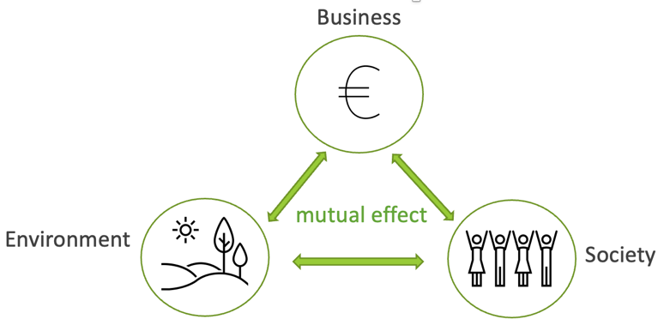
Why act sustainably?
- Unresponsible business behavior leads to many inequalities such as environmental degradation or social injustice
- Consequences of global population rise, threats of climate change, and dwindling natural resources are evident and can not be ignored
- The aim of being sustainable is to make a positive impact on at least one area (environment and society) which must be incorporated into the company’s unique vision and strategy
- Considering any sustainable goal and strategy in a company’s business requires perceiving its impact on the triple bottom line – profit, people, and planet
- Not all so-called “green solutions” are truly “green” and not all sustainable measures are necessarily costly

The Earth doesn’t produce unlimited natural resources. On the contrary, we live in a truncated world of resources called planetary boundaries that must be respected to avoid environmental, social, and economic consequences.

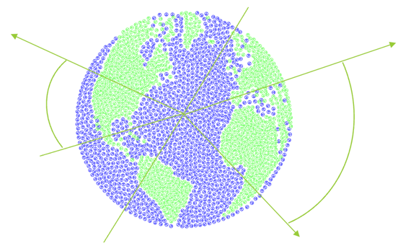

Watch the video about planetary boundaries and their current state here.

Section 1.2: Operational implications for MSMEs

Be aware of your company’s impact on the environment and society that foregoes sustainable solutions thus its strategy and goals. Don’t forget that setting goals for your company must be Specific, Measurable, Achievable, Relevant, and Time-bound – SMART

Does our company use sustainable materials in the manufacturing process?
Can our company rely on renewable energy sources?
How much waste does our company generate?
Are there any funds for supporting sustainable implications in a country?
Can our company sponsor or support any educational funds or vulnerable communities?
Is there any tool that helps measure a company’s carbon footprint?
Does our company hire diverse job candidates?
Does our company consciously reduce the amount of energy consumed?
Has our company approached circular economy principles?

Considerations of sustainable operational implications you can apply within your company include:
1. Energy efficiency: avoid wasting paper such as printing emails; turn off devices you don’t use; unplug electronics when not in use; ensure thermostats are set on the desired temperature; during washing dishes turn off the water; select electric devices with lower energy consumption or devices in a higher energy category (such as LED bulbs); lower degrees on your water heater; turn off AC or heating system when opening windows; educate your staff.
2. Supply chain management: Supply chain management: 1. analyze your supply chain (environmental, social, and economic issues); 2. apply social, environmental, and financial responsibility and circular supply chain features; 3. engage suppliers by putting sustainable issues in your regular business conversation or find a supplier with, e.g. ISO 14001 certification or similar you can incorporate into your business operations.
3. Waste management: use both sides of paper when you need to copy; recycle all waste types that can be sorted – try a challenge or competition for your employees such as collecting old toothbrushes for a reward; prefer reuse approach – donate or sell electronics, furniture, clothing, etc. for those in need or a secondhand store; reduce or compost your food waste if possible.
4. Sustainable procurement: is closely related to building a sustainable supply chain through sustainable purchasing, resulting in higher customer loyalty, positive impact on the environment, and reduce risk of non-compliance with legislation. Tips: 1. Purchase ethically sourced products (see ecolabels in Europe) & 2. Buy local goods to boost the local economy.
5. Community engagement: 1. even in a current time of social networking, bear in mind the importance of physical interaction with your clients and employees; 2. support your employee's activities in engaging with the local organizations; 3. use the potential of social media to interact with customers and to get their feedback; 4. be open and transparent by communicating your decisions (even future decisions) to your customers to get them in the loop of your business; 5. your company’s, employee’s, and community’s values should be aligned; 6. be passionate about listening and learning about your community to build strong relationships; 7. if you don’t know about community initiatives, visit your municipality website or simply ask your customers and employees how your company can get involved.
Check the Sustainable trends for MSMEs for 2023 by Dr. Ayman El Tarabishy

Micro, Small, and Medium-sized enterprises may struggle with the initial investment or lack of knowledge when it comes to the real implementation of sustainable practice... However, to think about sustainability in business you must consider all its three pillars: social, environmental, and economic. Watch this video and learn how you can create a sustainable impact through your business operations by using Sustainable Business Model Canvas.

Unit 2: Foundations for social entrepreneurship
Social entrepreneurship is a way to sustainably solve societal challenges!
According to the European Commission:
- There are 2.8 million social enterprises, representing 10% of all businesses in the EU.
- Almost 13.6 million people – about 6.2% of the EU’s employees – work for social enterprises.
- On top of the paid workforce, the social economy mobilizes volunteers, equivalent to 5.5 million full-time workers.
Based on the numbers, we can see that social entrepreneurship has a big potential to grow. The actual disadvantage is very low public exposure and recognition.
Let´s learn more about what social entrepreneurship is and what added value could your business gain with this approach!
Foundations for social entrepreneurship
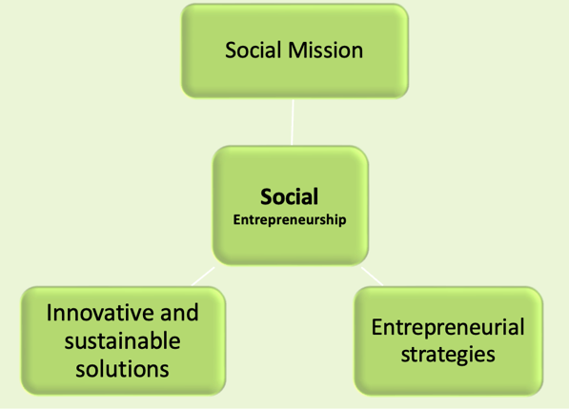
Source: Business Jargons, read more about social entrepreneurship here.
Section 2.1: How is social entrepreneurship different?
In general, entrepreneurship is based on profit maximization and this profit can be divided among the owners. Social enterprise can operate in any field and generates profit as any other business - the difference is how the profit is used!
The profit is reinvested and fulfills a clear social mission that positively impacts a community!
Social enterprises reinvest a certain share of their profit based on the relevant national law – e.g. Social enterprises in Slovakia put more than 50% of the profit back into the organization to expand and improve their services and activities that they carry out in order to fulfill their socially beneficial goals.

Social enterprises vs. profit-maximizing business and non-profit organisations:
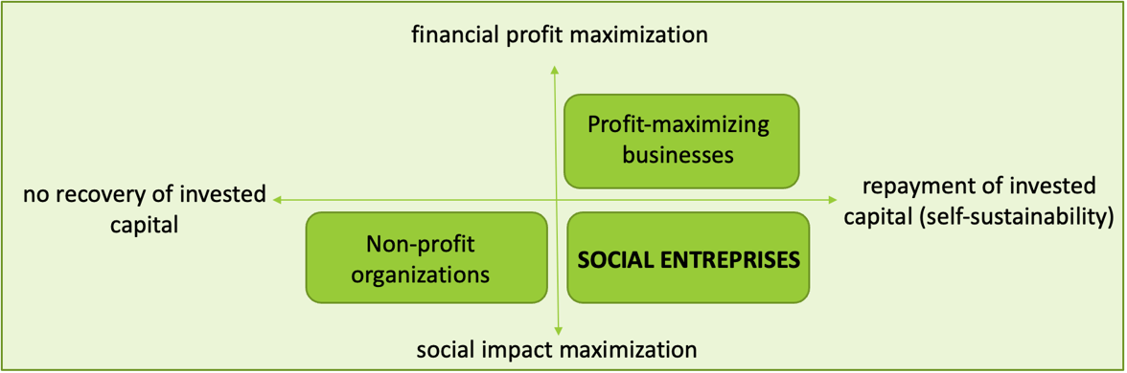
Source: Building Social Business Models: Lessons from the Grameen Experience Muhammad Yunus, Bertrand Moingeon and Laurence Lehmann-Ortega

Often, in the eyes of the public, social entrepreneurship is mainly associated with the integration of disadvantaged people.
BUT social missions can support the community’s well-being in many other fields than job creation and social inclusion of vulnerable groups, for example, cultural needs, healthcare, environmental protection, etc.
For a better picture of the answer to the question „What is Social Entrepreneurship?“ watch the video created by Cluster for Eco-Social Innovation and Development CEDRA Split.
Check examples of successful social enterprises and social innovation projects in selected countries described in the Handbook on Social Innovation prepared by experts from Slovakia or good practices identified within the project BRESE, Interreg Europe.

Section 2.2: Social entrepreneurship vs. Corporate social responsibility (CSR)
Corporate social responsibility (CSR) is a self-regulating business model that helps a company be socially accountable to itself, its stakeholders, and the public.
A socially responsible company voluntarily carries out activities that contribute, for example, to the protection of the environment or the development of the community, (they release employees to perform volunteer activities, financially support cultural events, etc.) - BUT its primary goal is still the creation of profit!
While the primary goal of a social enterprise is the fulfillment of the social mission, the creation of social benefits, and a positive impact on the community.

Social entreprise - The primary goal is the fulfillment of the social mission!
Socially responsible company - The primary goal is profit maximization!

Section 2.3: Social mission in MSMEs
Advantages
- Added value of the social enterprise is created by implementing social change.
- Support from the target community, volunteers can also be involved in the organization's activities.
- It is estimated that partnering with and supporting social entrepreneurs could have a positive impact on the lives of nearly 1 billion people.
- Growing support from the European Commission - the European Commission prepared Action Plan to boost the social economy and create jobs.
Challenges
- Not forgetting about the entrepreneurial spirit within the social enterprises. Profit is needed for the company’s growth and social impact maximization.
- Effective communication of the identified social problem and solutions that the social enterprise is offering to increase public exposure and recognition of social enterprises.
- To get the trust of others.

Unit 3: Green entrepreneurship
Green entrepreneurship is a subset of sustainable entrepreneurship that addresses mainly environmental concerns but also social change through its products, services, and operations while generating profit. Green entrepreneurs are thus entrepreneurs who work towards the elimination of negative impact on the environment, by:
- reduction of greenhouse gas emissions and waste generation;
- improvement of energy efficiency and investment in renewable energy resources;
- protection and restoration of natural ecosystems;
- production and consumption of environmentally friendly products and materials.

Section 3.1: What is green entrepreneurship and its principles
To make an impact, green entrepreneurs must communicate information about their sustainable activities and inform all stakeholders about it. However, this is preceded by the specific set of goals and the correct selection of tools to measure progress (such as monitoring the environmental impact of production operations and products during the whole lifecycle). Additionally, successful green entrepreneurship is desirable for the customers’ swift of their consumption to be more consciousness one.
Set goals Inform about your pledges Monitor goals Share the progress Educate your customers
How to boost the idea of green entrepreneurship in your business?
Watch the successful story of green entrepreneurship and get inspired by the natural ecosystem of the Earth Click here
Take note that green entrepreneurship is based on making a real positive impact on the environment and society around us. It’s not about the greenwashing practices!

Section 3.2: How to leverage the potential of green entrepreneurship
“All sectors of the economy will have to change for the world to decarbonize, upending established markets and creating new ones. Achieving a net-zero world by 2050 may well prove to be the largest reallocation of capital in history.” -McKinsey, 2022

Level of sustainable opportunity based on technological maturity and climate impact:
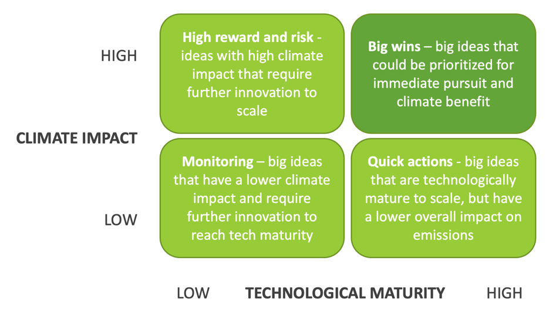
Source: own processing according to https://www.mckinsey.com/industries/industrials-and-electronics/our-insights/identifying-opportunities-and-starting-to-build-a-new-green-business-in-the-industrial-sector

Explore 5 steps that can help you mitigate risk and evaluate your sustainable opportunities by McKinsey & Company (from mapping opportunities for industrial companies along 11 customer sectors: agriculture and land and forest management, buildings, carbon management, consumer goods, hydrogen, industrials, oil and gas, power, transportation, waste, and water):

1. Assess the value prospects
- McKinsey estimates that $9 trillion to $12 trillion in sustainability investment opportunities will emerge by 2030
- Companies may benefit from identifying specific investment themes within different sectors and assessing the value of each theme
- By providing more clarity about the potential for value, such segmentations can help leaders not only to prioritize their opportunities but also to build support for new green ventures
2. Identify important technology and infrastructure enablers
- Companies should determine if any factors such as infrastructure, supply chain, customer base, and geographic footprint give them an edge
- After completing the internal assessment, companies should review the opportunities they have identified in the first step and consider their existing capabilities such as skills and facilities
- Companies may discover that their capabilities are a strong fit for an opportunity they had not originally considered
- Each company will reach a different conclusion after the internal review due to its unique strengths and weaknesses
- Machinery companies that specialize in drive technology might achieve the best results by focusing on electrode coaters. Those involved with robotics and automation might win by concentrating on cell or pack assembly tools
3. Base priorities on climate impact and technological maturity
- Different companies may have varying attitudes about the climate impact and technological maturity they want, with some companies having a high-risk appetite for emerging technologies that could deliver promising returns and others being less comfortable with immature technologies despite their potential sustainability impact
- To assess the impact on climate companies can use tools that determine the baseline sustainability metrics of a company, product, or process and predicts how different solutions could improve these metrics
- To assess the maturity of a technology, companies can use their proprietary research and analytical tools to help companies determine the abatement prospects of a technology by evaluating its level of maturity
4. Align with future policies and regulations
- Regulations such as the EU Fit for 55 package could act as catalysts by creating incentives for the development of green products or providing economic benefits to companies that cut emissions
- Companies should follow regulatory developments and consider how current or future policies might affect their strategies, particularly for green businesses as regulations are often missing, nascent, or rapidly evolving
5. Define a strong business case and plan
- Before executing a green strategy, companies could benefit from developing a complete business plan, including a business case with a five- to ten-year outlook
- When developing business plans, companies may benefit from asking some basic questions, including:
- What are the company's financial and non-financial goals?
- What is the current market demand?
- What is the ideal market position?
- How can the company address skill deficiencies while expanding the business?
- In which areas should the company focus its efforts?
- How can the company measure and track progress during implementation?

Don’t forget…
Get certified – Consider having your company or products certified by a certification body. It can be also a valuable marketing tool to help create a sense of trust with customers and other stakeholders.
Leverage government incentives - To make it easier to implement sustainable solutions, green entrepreneurs should explore the various government incentives such as grants, tax credits, and loans that are available to support sustainable business practices.

Challenges for industrial companies that might amend their sustainable path:
- Unclear market size and growth rates - The revenue forecast for some green products is uncertain. For example, carbon capture technology is a small market but is predicted to grow significantly, even though it is hard to predict its exact size.
- Early-stage technologies - Sustainable products are in the early stages of development and it is unclear if they will be feasible on a large scale. The sustainable production of hydrogen, for example, requires new and efficient electrolyzers, but the best technology and infrastructure are still being researched.
- A lack of clarity about the required competencies, facilities, and product characteristics - Companies are still identifying unique selling points for green products, for example, battery cells, and the specific requirements for next-generation batteries are still uncertain. This uncertainty also makes it difficult to predict the necessary skills, materials, and facilities required to produce these products.
- Changing regulations - Companies are uncertain about the future impact of rapidly evolving sustainability regulations on their products and services and cannot be sure that they will meet future guidelines until they have more details about which, when, and where regulations will apply.

Section 3.3: Tips & Tools to make your business “greener”
Not sure about your impact on the environment? The knowledge of the current state precedes every change. Measure your carbon Footprint and see which activity within your company generates the highest negative impact on the environment by using Free Carbon Calculators:
- United Nations Carbon Footprint Calculator
- World Wildlife Fund Footprint Calculator
- The Nature Conservancy Carbon Footprint Calculator
- Global Footprint Network Ecological Footprint Calculator
- United States Environmental Protection Agency Carbon Footprint Calculator

Contents in bullet points
[summary of the contents in bullet points]
- Sustainable in business refers to doing business without negatively impacting the environment, society, community, and economy.
- Sustainable approach can be implemented by operational implications concerning components such as energy efficiency, supply chain management, waste management, sustainable procurement, and community engagement.
- Social enterprise can operate in any field and generates profit as any other business - the difference is how the profit is used! The profit is reinvested and fulfills a clear social mission that positively impacts a community!
- Significant added value of the social enterprise is created by implementing social change.
- Green entrepreneurship work towards the elimination of the negative impact on the environment by reducing greenhouse gas emissions and waste generation; increasing energy efficiency and investments in renewable energy resources; protecting the natural ecosystems and producing environmentally friendly products.
- Green entrepreneurship should be inspired by natural ecosystems.
- Green entrepreneurship represents a huge business opportunity for the decarbonized world by 2050.

5 glossary entries
Sustainability. A concept that discusses how we live today so that our children and grandchildren can thrive.

Social entrepreneurship. Social Entrepreneurship refers to a process of doing business with an aim of resolving the most serious and daunting, social, cultural and environmental issues and improve the lifestyle of the people living the community.
Social enterprises. Social enterprises reinvest a certain share of their profit back into the organization to expand and improve the services and activities that they carry out in order to fulfill their socially beneficial goals. The amount of reinvested money depends on the national law of the country they operate in. However, social enterprise can operate in any field and generates profit as any other business.

Green entrepreneurship. Green entrepreneurship is a subset of sustainable entrepreneurship that addresses mainly environmental concerns but also social change through its products, services, and operations while generating profit.

Greenwashing. Company which shares untrue or misleading information about its sustainable actions for its marketing purposes.
Bibliography and further references
[sources and references of the contents; format of the reference: link; please use only relevant sources, do not cite Wikipedia]
- Business Jargons. (2022). Social Entrepreneurship. https://businessjargons.com/social-entrepreneurship.html
- Earth Overshoot Day. (2022). Past Earth Overshoot Days. https://www.overshootday.org/newsroom/past-earth-overshoot-days/
- European Commission. (2022). Internal Market, Industry, Entrepreneurship and SMEs. https://single-market-economy.ec.europa.eu/sectors/proximity-and-social-economy/social-economy-eu_en
- European Commission. (2022). Social Economy Action Plan. https://ec.europa.eu/social/main.jsp?catId=1537&langId=en
- European Union. (2021, September 07). How to reduce my carbon footprint?. https://youth.europa.eu/get-involved/sustainable-development/how-reduce-my-carbon-footprint_en
- Forbes. (2019, February 22). Seven Ways To Build Community Engagement And Grow Your Business. https://www.forbes.com/sites/forbeschicagocouncil/2019/02/22/eight-ways-to-build-community-engagement-and-grow-your-business/?sh=6e27f6395cb8
- FSB. (2021, October 19). How to achieve sustainable procurement. https://www.fsb.org.uk/resources-page/how-to-achieve-sustainable-procurement.html
- Gatley N. (2021, September 10). How to build a sustainable supply chain https://www.british-assessment.co.uk/insights/how-build-sustainable-supply-chain/
- Georgetown University. Simple Tips to Reduce Your Carbon Footprint. Top 10 Ways to Save Energy. https://sustainability.georgetown.edu/community-engagement/things-you-can-do/
- Herring D. et al. (2022, October 21). Identifying opportunities and starting to build a new green business in the industrial sector. https://www.mckinsey.com/industries/industrials-and-electronics/our-insights/identifying-opportunities-and-starting-to-build-a-new-green-business-in-the-industrial-sector
- Cho R. (2018, December 27). The 35 Easiest Ways to Reduce Your Carbon Footprint. https://news.climate.columbia.edu/2018/12/27/35-ways-reduce-carbon-footprint/
- IBM. What is sustainability in business?. https://www.ibm.com/topics/business-sustainability
- Fernando J. (2022, May 27). Corporate Social Responsibility (CSR) Explained With Examples. https://www.investopedia.com/terms/c/corp-social-responsibility.asp
- Yunus M., Moingeon B. and Lehmann-Ortega L. (2010). Building Social Business Models: Lessons from the Grameen Experience. https://web.archive.org/web/20160203162342/http:/www.hec.edu/content/download/52956/470943/file/Article%20LRP%20Yunus%20Moingeon%20Lehmann-Ortega%20d%C3%A9finitif.pdf
- Navarathinam K. & Amutha V. (2022). GREEN ENTREPRENEURSHIP: A SUSTAINABLE DEVELOPMENT INITIATIVE WITH SPECIAL REFERENCE TO SELECTED DISTRICTS. https://www.journalppw.com/index.php/jpsp/article/view/4675/3083
- Polačková Z. (2020). SOCIAL ENTERPRISES AND THEIR ECOSYSTEMS IN EUROPE. Country report SLOVAKIA. https://ec.europa.eu/social/BlobServlet?docId=22453&langId=en
- Saari A. U. & Joensuu-Salo S. (2022, January 01). Green Entrepreneurship. https://link.springer.com/referenceworkentry/10.1007/978-3-319-95726-5_6
- SEFE Energy. Guide: How to improve your business’ energy efficiency. https://www.sefe-energy.co.uk/energy-guides/how-to-improve-your-business-energy-efficiency/
- Spiliakos A. (2018, October 14). What does “Sustainability” mean in business”. https://online.hbs.edu/blog/post/what-is-sustainability-in-business
- United Nations. United Nations Conference on the Human Environment, 5-16 June 1972, Stockholm. https://www.un.org/en/conferences/environment/stockholm1972
- World Economic Forum. (2021, January 19). 5 ways business can support and partner with social entrepreneurs. https://www.weforum.org/agenda/2021/01/5-ways-business-can-support-and-partner-with-social-entrepreneurs/

Five multiple-choice self-assessment questions  Upon completion of the validation mechanism with 75% of correct answers, users will be able to generate customised Certificate of Attendance and Certificate of Completion. |  | Question 1. Business sustainability refers to:  Option a: Actions impacting society positively  Option b: Actions decreasing profit in a company  Option c: Actions impacting the environment positively  Option d: All of the above  Correct option: a: Actions impacting society positively; c: Actions impacting the environment positively  Question 2. A sustainable approach addresses the following factors at the same time:  Option a: environmental, economic, social  Option b: environmental, social, physiological  Option c: environmental, economic, technocratic  Option d: None is correct  Correct option: a: environmental, economic, social  Question 3. Social enterprise:  Option a: use its profit to fulfill its social mission  Option b: has the main goal of profit maximization and voluntarily supports publicly beneficial activities  Option c: does not make a profit and responds to social problems with its activities  Option d: None is correct  Correct option: a: use its profit to fulfill its social mission  Question 4. How does a social enterprise deal with profit?  Option a: never makes a profit  Option b: distributes the entire profit among the owners  Option c: certain part of the profit is compulsorily reinvested in the fulfillment of its clear social mission that positively impacts a community  Option d: None is correct  Correct option: c: certain part of the profit is compulsorily reinvested in the fulfillment of its clear social mission that positively impacts a community  Question 5. Green entrepreneurship refers to:  Option a: greenwashing practices  Option b: technological innovations  Option c: business that addresses mainly environmental concerns  Option d: All of the above  Correct option: c: business that addresses mainly environmental concerns  Question 6. Decarbonization and the associated achievement of carbon neutrality by 2050 may represent:  Option a: the largest capital reallocation in history  Option b: the lowest capital reallocation in history  Option c: the largest natural resources reallocation in history  Option d: None is correct  Correct option: a: the largest capital reallocation in history
Related material |  | [related material - field is to indicate the name of the ppt file that accompanies the file, so that when IWS uploads the materials to the backoffice, they are sure that they are uploading the correct files]  RESTART_PR3_05_SBA_Sustainable, social, and green entrepreneurship
Reference link |  | [reference link if any - field is intended for a more specific/in-depth link that is closely related to the module. For example, a link to a pdf from another website, etc.]  https://www.un.org/en/conferences/environment/stockholm1972  https://www.un.org/en/conferences/environment/rio1992  https://www.un.org/en/conferences/environment/newyork2015  https://www.stockholm50.global/news-and-stories/why-does-stockholm50-matter-what-did-it-achieve-what-does-it-offer-going-forward  https://wedocs.unep.org/bitstream/handle/20.500.11822/40110/Key%20Messages%20and%20Recommendations%20-%20Formatted.pdf?sequence=1&isAllowed=y  https://www.supplychain247.com/article/circular_supply_chain_the_missing_link/Kuebix  https://www.ecolabelindex.com/ecolabels/?st=region=europe  https://www.businessnewsdaily.com/7832-social-media-for-business.html  https://icsb.org/toptrends2023/  https://single-market-economy.ec.europa.eu/sectors/proximity-and-social-economy/social-economy-eu_en  https://businessjargons.com/social-entrepreneurship.html  https://web.archive.org/web/20160203162342/http:/www.hec.edu/content/download/52956/470943/file/Article%20LRP%20Yunus%20Moingeon%20Lehmann-Ortega%20d%C3%A9finitif.pdf  https://www.mirri.gov.sk/wp-content/uploads/2021/08/Handbook-on-Social-Innovation_27062021.pdf  https://projects2014-2020.interregeurope.eu/brese/good-practices/  https://www.investopedia.com/terms/c/corp-social-responsibility.asp  https://www.weforum.org/agenda/2021/01/5-ways-business-can-support-and-partner-with-social-entrepreneurs/  https://ec.europa.eu/social/main.jsp?catId=1537&langId=en  https://greenbusinessbureau.com/topics/green-team/measuring-sustainability-as-an-internal-process-of-a-company/  https://www.consilium.europa.eu/en/policies/green-deal/fit-for-55-the-eu-plan-for-a-green-transition/  https://offset.climateneutralnow.org/footprintcalc  https://footprint.wwf.org.uk/#/  https://www.nature.org/en-us/get-involved/how-to-help/carbon-footprint-calculator/  https://www.footprintcalculator.org/home/en  https://www3.epa.gov/carbon-footprint-calculator/
Video in YouTube format (if any) |  | [video link if any]  https://www.youtube.com/watch?v=zx04Kl8y4dE  https://www.youtube.com/watch?v=9SVYnKKOG-w  https://www.youtube.com/watch?v=fYhpfI_JIMU  https://www.youtube.com/watch?v=aTo0qtdVMpM  https://www.youtube.com/watch?v=TxwGZppT2WA  https://www.youtube.com/watch?v=5_SGWaAcyyw

