RESTART: Resilience and Training for SMEs

Case study template
(Project Result 3 - Task 3.1. & Task 3.2)

Author of the case study: | Slovak Business Agency
Name of the module to which the case study is assigned: | Module 5: Sustainable, social, and green entrepreneurship
Title of the case study: | AfB social & green IT - European largest social enterprise in the field of a refurbishment of used IT hardware
Description of the case study: | AfB was founded in 2004 and currently operates in Germany, Slovakia, Austria, Switzerland, and France. It is a social enterprise that solves both the social and environmental challenges of society.  It currently employs approximately 600 employees, roughly half of whom are employees with disabilities.  Its environmental contribution and the application of circular economy principles in the field of IT equipment recovery are also significant: "In 2022, the AfB company reached a record number of 528,000 processed IT and mobile devices. Compared to the previous year, it significantly increased its device remarketing rate to 64%, giving a second chance at life to up to two out of three devices processed. By extending the life of the equipment, the AfB company, compared to the production of new equipment, has saved 22,800 tons of natural raw materials and 170,800 MWh of primary energy. It saved 318 million liters of water and 44,700 tons of greenhouse gases.”  AfB takes discarded hardware from partner companies (more than 1,000) in which it certifiably removes data and then modifies it so that it can be used again. It is proud of the "Microsoft Authorized Refurbisher (MAR)" sign and provides a complete package of services to its clients (taking over, refurbishing, hardware recycling, etc.). AfB also offers support services, including software installation and IT servicing. Additionally, through cooperation with partners, this refurbished IT technology also finds "a new home" in schools and centers in less developed regions in Slovakia.  In the long term, AfB plans to fill 500 jobs for employees with disabilities and become a world leader in IT social entrepreneurship.  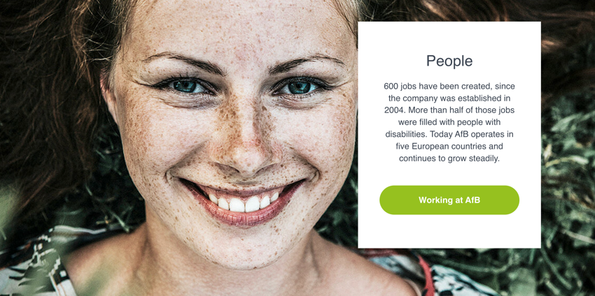  Source of the photo: https://www.afb-group.sk/o-nas/ludske-zdroje/
Link for further information: | https://www.afb-group.sk/home/  https://projects2014-2020.interregeurope.eu/policylearning/good-practices/item/5233/afb-social-green-european-first-non-profit-it-company-in-the-field-of-refurbishment-of-it-hardware/
Target group of the case study: | Micro, Small & Medium Enterprises (MSMEs)  Employees of MSMEs   The EU VET ecosystem    Business support organizations
ESCO competencies and skills
- Transversal skills and competences
- Social and emotional skills
- Critical thinking
- Analytical thinking
- Problem-solving
- Self-management
- Business management
- Adaptability
- Resilience
- Creativity
- Networking
- Initiative
- Flexibility
- Openness
- Understanding complexity
- Cooperation
- Empathy
- Innovation
- Leadership

- Skills
- Technological skills
- Product marketing
- Digital marketing
- Digital skills
- Communication
- Cooperation
- Emotional intelligence

- Knowledge
- Business management
- Online learning and training
- Advertising
- Cloud computing
- Big data
- E-commerce
- Artificial intelligence
- IoT
- Digital literacy
- Cybersecurity
- Data mining and analysis
- Sustainability
- Well-being
- Climate change
- Social media management

