RESTART: Resilience and Training for SMEs

Case study template
(Project Result 3 - Task 3.1. & Task 3.2)

Author of the case study: | Slovak Business Agency
Name of the module to which the case study is assigned: | Module 5: Sustainable, social, and green entrepreneurship
Title of the case study: | CILA - leader in ethical fashion with a focus on capsule collections
Description of the case study: | The Fast Fashion industry has faced criticism for a long time due to the high ecological burden and unfavorable working conditions of employees. On the other hand, the concept of Slow fashion solves the mentioned challenges and takes a responsible and considerate approach to the environment and the workforce. Cila is a Slovak fashion brand that rightfully belongs to the Slow fashion category. The intention to start the company was based on the idea of creating high-quality, comfortable, and timeless clothes that people would wear for longer and would not end up as waste.  Cila creates clothing for women who care about a sustainable lifestyle. Sustainability, social responsibility, and female power are therefore at the center of its business. They focus on the durability of their products and local production in Slovakia. What is their exact approach?  - Proposals are created in cooperation with the female "audience"  - They get the materials from local workshops in Slovakia in the form of high-quality textile "waste", which is subsequently upcycled - they mainly choose organic certified fabrics  - Buttons that are no longer used are also given a second chance  - Production takes place in smaller workshops with experienced seamstresses  - Only recycled paper is used for packaging  - Remnants of material left over from production go to schools, textile waste processors or are used in packaging  In 2017, the brand was awarded the Via Bona Slovakia prize for an inspiring project in the Green Company category, awarded by the well-known Slovak Pontis Foundation. And in 2020, the company reached the final in the same category.  Since its inception, Cila has been based on transparency and does not build a brand as a trend. It publishes all available information and descriptions of products and their origin. Cila also considers empathy to be important and actively builds relationships with customers at various events where the company can present itself.  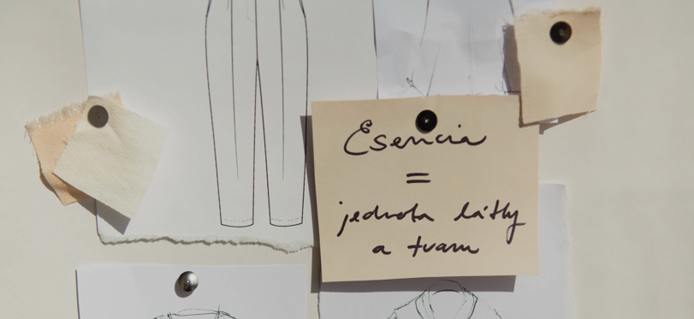  Source of the photos: https://cilaatelier.sk/
Link for further information: | https://cilaatelier.sk/
Target group of the case study: |  Micro, Small & Medium Enterprises (MSMEs)    Employees of MSMEs   The EU VET ecosystem    Business support organizations
ESCO competencies and skills
- Transversal skills and competences
- Social and emotional skills
- Critical thinking
- Analytical thinking
- Problem-solving
- Self-management
- Business management
- Adaptability
- Resilience
- Creativity
- Networking
- Initiative
- Flexibility
- Openness
- Understanding complexity
- Cooperation
- Empathy
- Innovation
- Leadership

- Skills
- Technological skills
- Product marketing
- Digital marketing
- Digital skills
- Communication
- Cooperation
- Emotional intelligence

- Knowledge
- Business management
- Online learning and training
- Advertising
- Cloud computing
- Big data
- E-commerce
- Artificial intelligence
- IoT
- Digital literacy
- Cybersecurity
- Data mining and analysis
- Sustainability
- Well-being
- Climate change
- Social media management

